NOS-120 Chapter 3

Log into NDG and workstation virtual Classroom Machine to complete this quiz.

1. Type the command that will display the full path name of the current working directory for that shell.

Insert Screenshot Below:

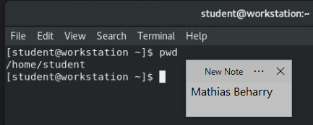

1. Type the command to create a directory name Quiz3.

Insert Screenshot Below:

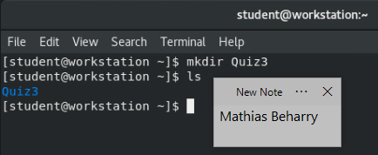

1. Type the command that to change your shells current working directory to Quiz3.

Insert Screenshot Below:

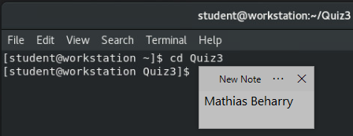

1. Type the command that to create five empty files. The file names should be demo1, demo2, demo3, demo4, and demo5. Run the ls command in the Quiz3 directory to confirm that you created these files successfully.

Insert Screenshot Below:

